**Driving Learners Test APP Domain Model**

**Introduction**

Apps are always an easy and useful tool as they can be installed on our mobile devices that we always carry all the time. The Driving Learners Test App assist in preparing people for their Driving Learners Exam by providing an exercise similar to the books or electronic documents that are given by the traffic department. This app is helpful as it can be use prior to the Test day and after to test knowledge about the road safety rules.

**Class Diagram of the Domain Model**

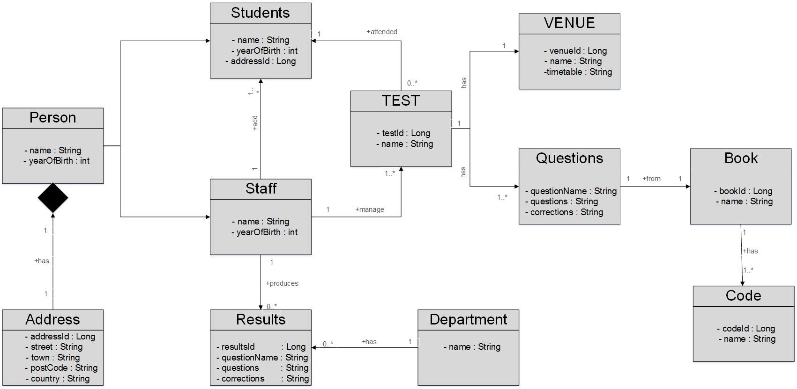

**Description of the Domain Model**

Each session will be managed by an assigned Staff and that staff will also play an Administration role. The staff adds Learners/Students on to the Attendance list on date. Each registered Learner can take a Test that is dependent on the “Code” it is registered under by the Administrator.

A person registered Attend an Exam at a specified Venue and time. The venues are only used on a scheduled time on the Timetable. After the test have been conducted then the Department Produces Results.

There are 3 types of codes: namely A, B, C or Motorcycles, Light Motor Vehicles, Heavy Vehicles with each of these codes assigned to their specific Books. These Books carry information that Questions are generated from to test a Learner knowledge about South African Road Safety Rules.